# Use Case 2 – Create and monitor a Copy Job in data factory for Microsoft Fabric

## Exercise 1 – Setting up the Environment

### **Task-1: Create a New Workspace**

To create a workspace:

1. From left pane, select **Workspaces** > **New workspace**.

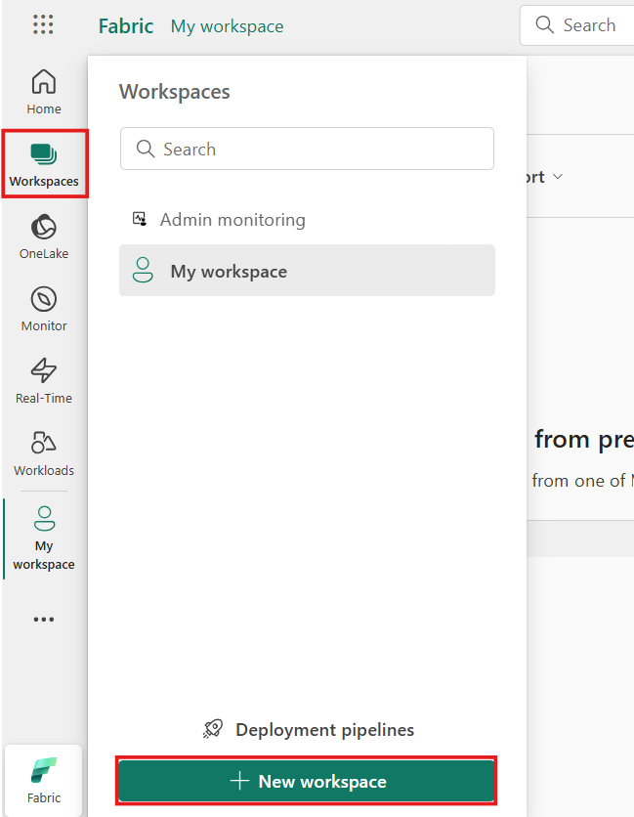

1. In the **Create a workspace** tab, enter the following details and click on the **Apply** button.

|  |  |
| --- | --- |
| **Name** | *Enter a unique name. for example –* ***DataFactory_Fabric*** |
| **Advanced** | Under **License mode**, select **Trial** |
| **Default storage format** | Small semantic model storage format |

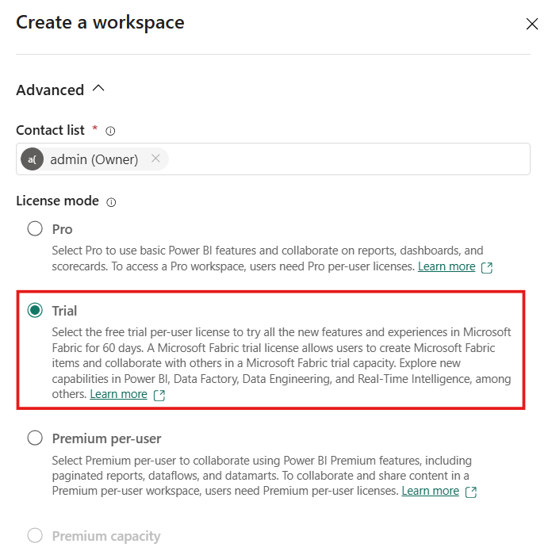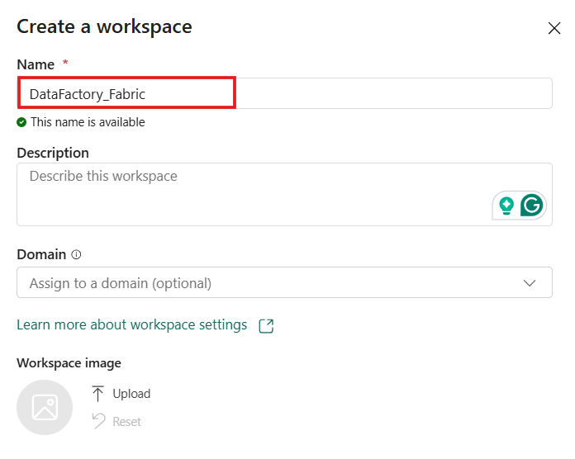

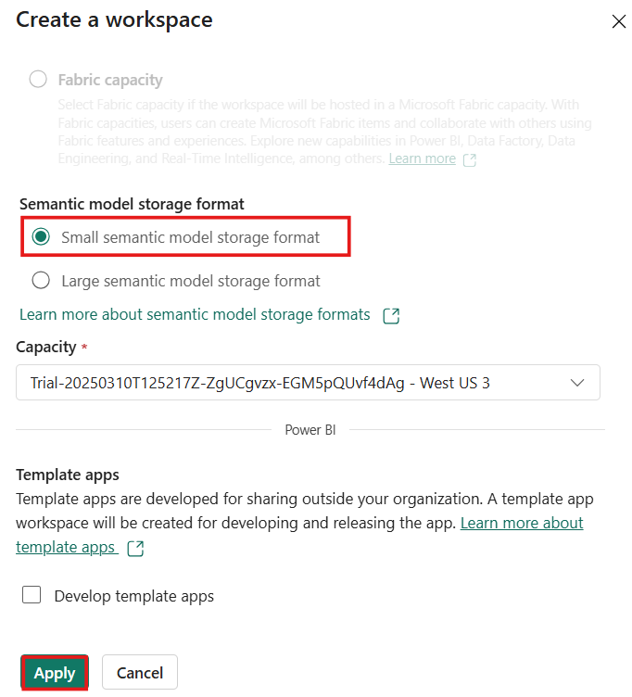

### **Task-2: Create a Warehouse with sample data**

1. 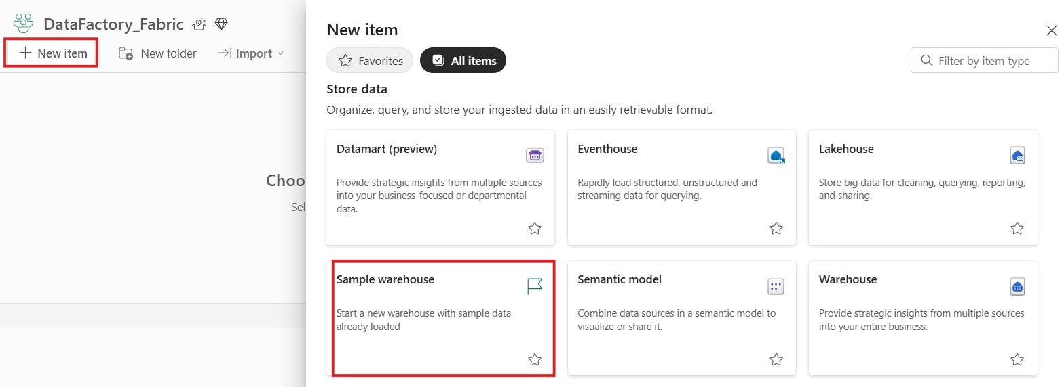In the **DataFactory_Fabric Workspace** page, select **+New Item and Look for the Sample warehouse card under Store Data section.**
2. 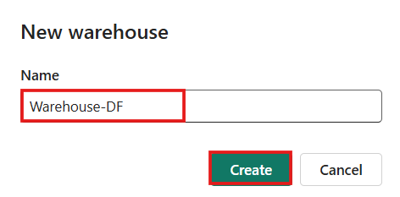On the **New warehouse** dialog, provide a name for your warehouse as **Warehouse-DF** and click on the **Create** button.
3. 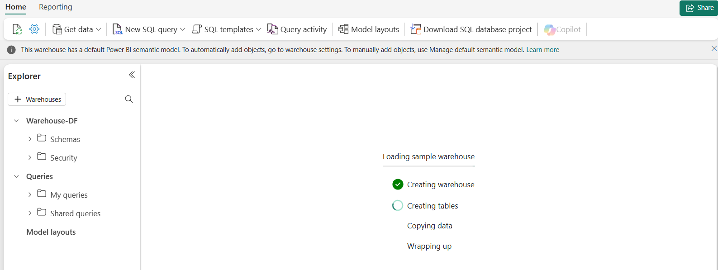The create action creates a new Warehouse and start loading sample data into it. The data loading takes few minutes to complete.
4. On completion of loading sample data, the warehouse opens with sample data loaded into tables and views to query.

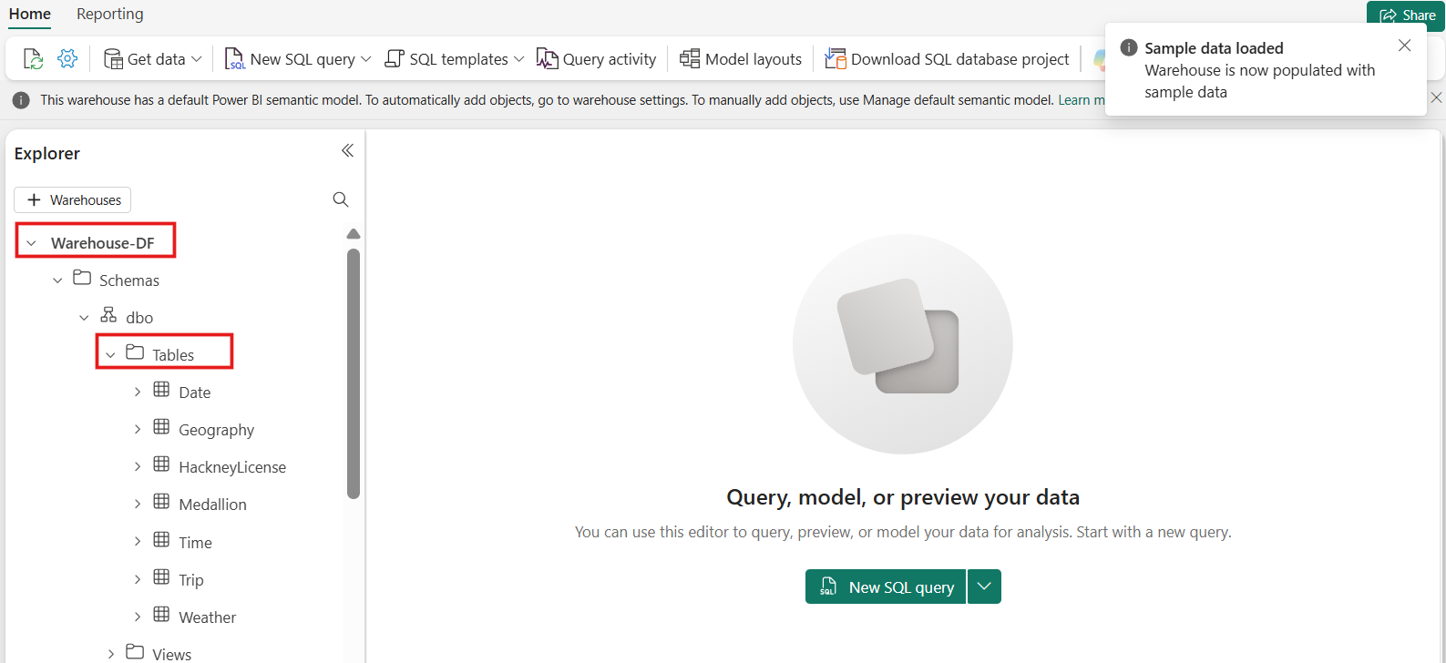

## Exercise 2 - Create a Copy job in Data Factory

### **Task-1: Create a Copy job in Data Factory**

Complete the following steps to create a new Copy job:

1. 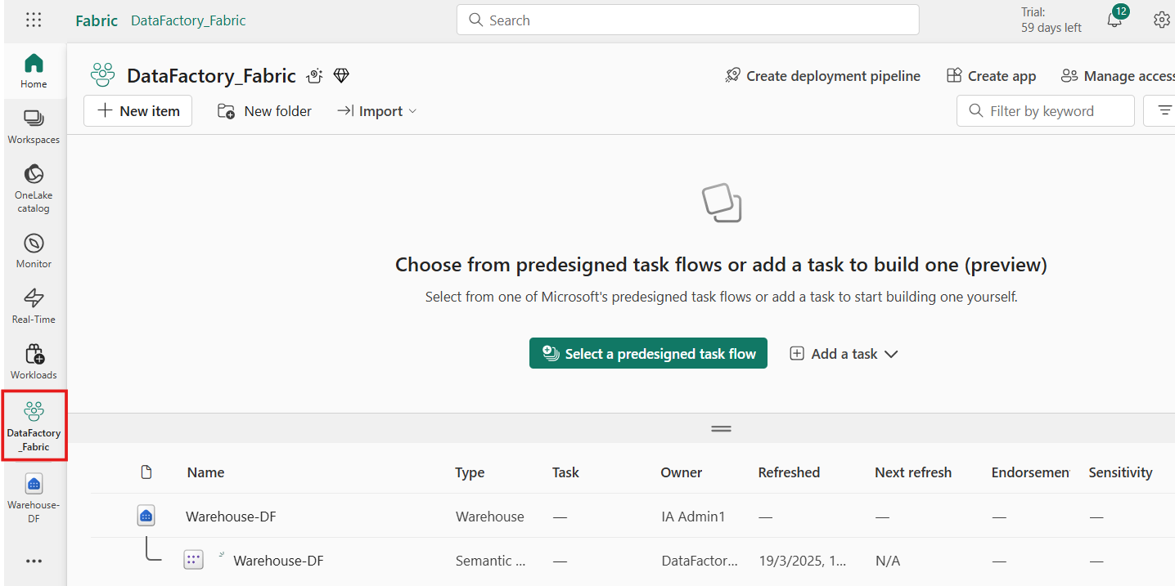Navigate to the existing workspace i.e., Warehouse-DF page.
2. 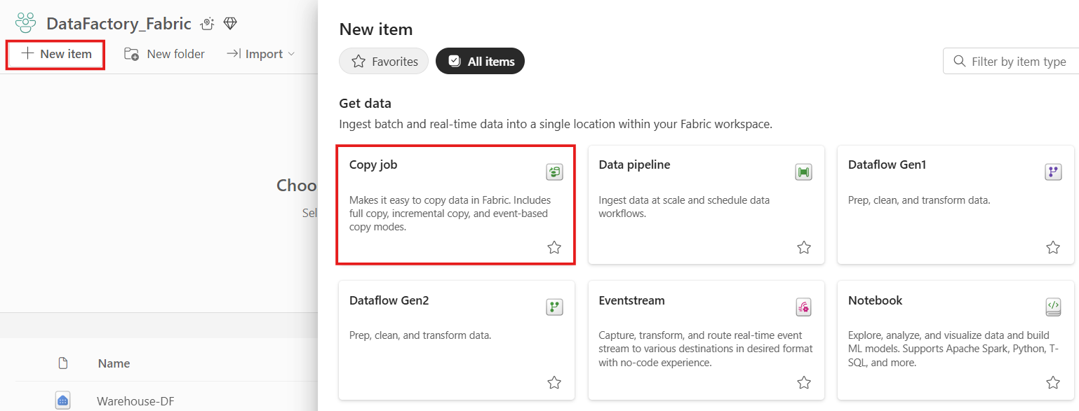Select **+New item** option and choose the **Copy job** card to create a new Copy job.
3. 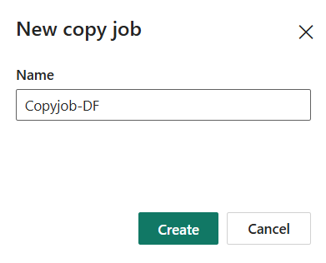Assign a name to the new job, then select **Create**.
4. For this lab, we are considering Warehouse as the data source which we have created initially. Hence, Choose the data stores as **Warehouse-DF** to copy data from.

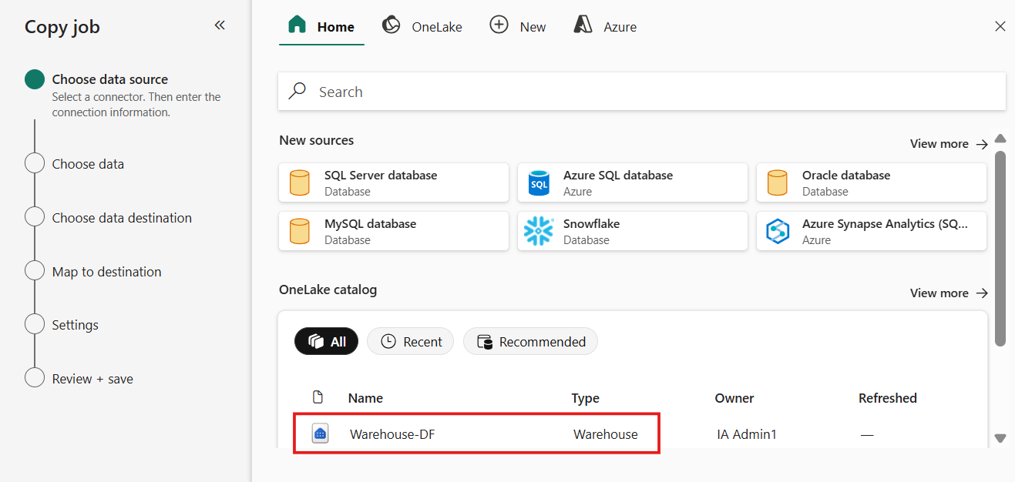

1. 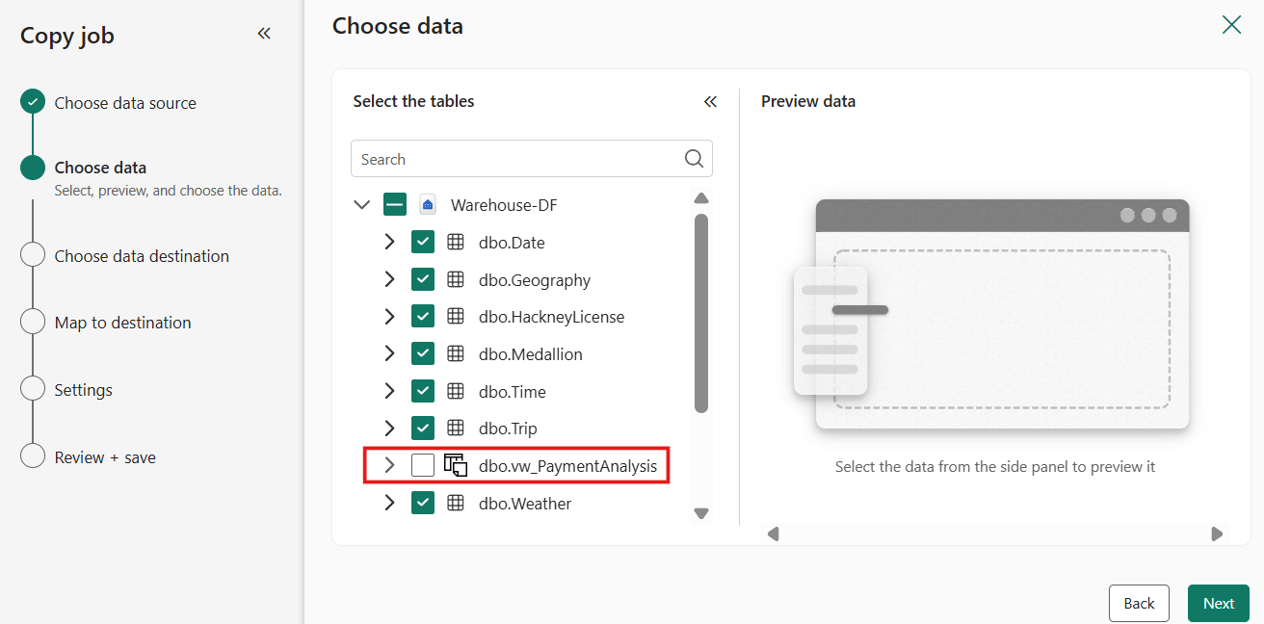Select the tables and columns you wish to copy by selecting the **checkboxes**. You can remove the views represented with a different symbol as shown below. Click on **Next**.
2. 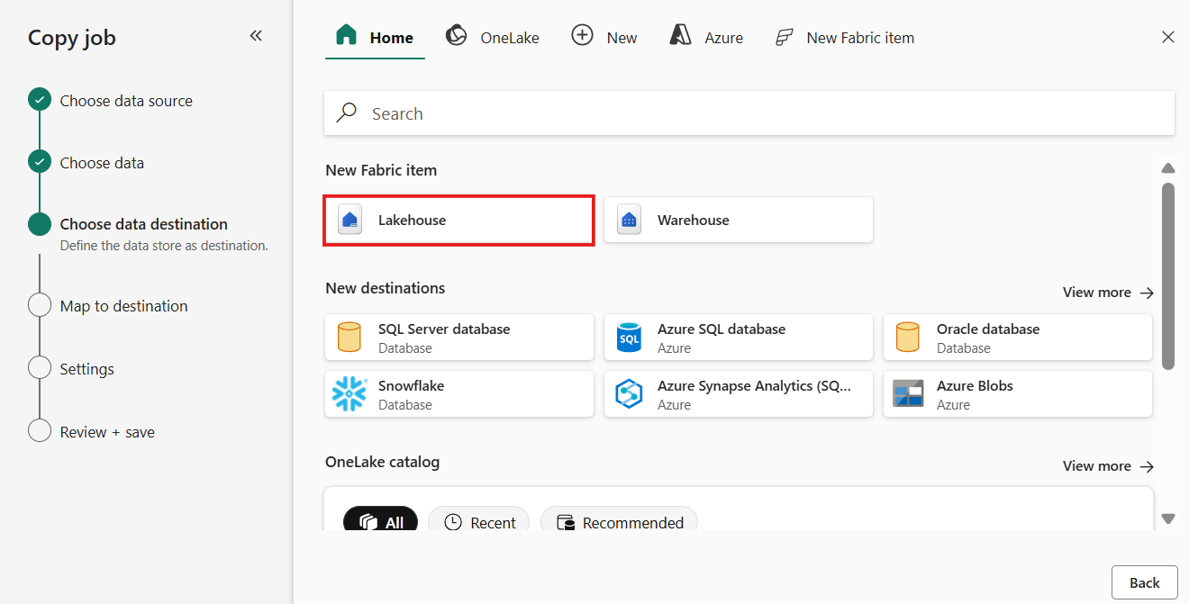For this lab, we are considering Lakehouse as the data destination. So, to create a new **lakehouse** for copying the data from the data source i.e, warehouse to this lakehouse using copy job, select your **destination store** as **Lakehouse** under New Fabric item
3. 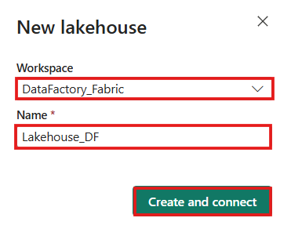Select the **Workspace** name from the drop-down and provide a name to the **lakehouse**.
4. 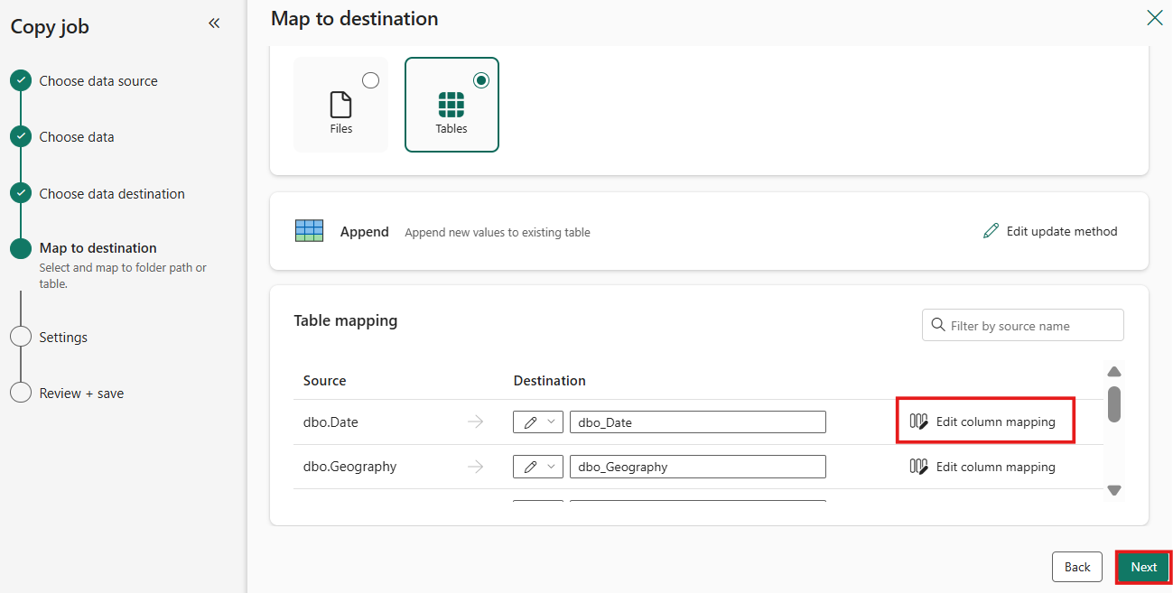Configure table or column mapping if you need using **Edit column mapping** option.
5. 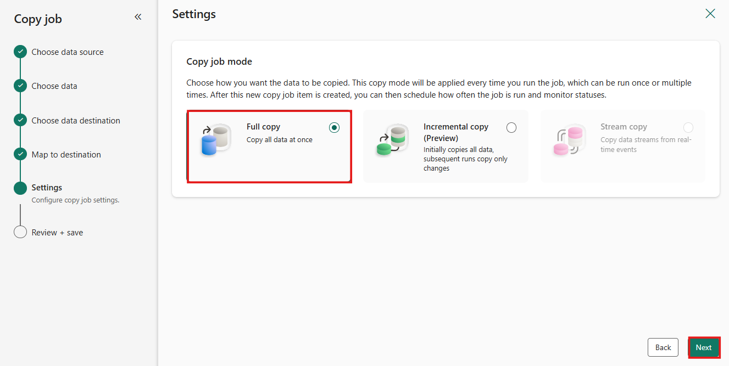Choose the copy mode, either a one-time full data copy, or continuous incremental copying. For this lab, we are moving ahead with **full copy** option. Click on **Next**.
6. 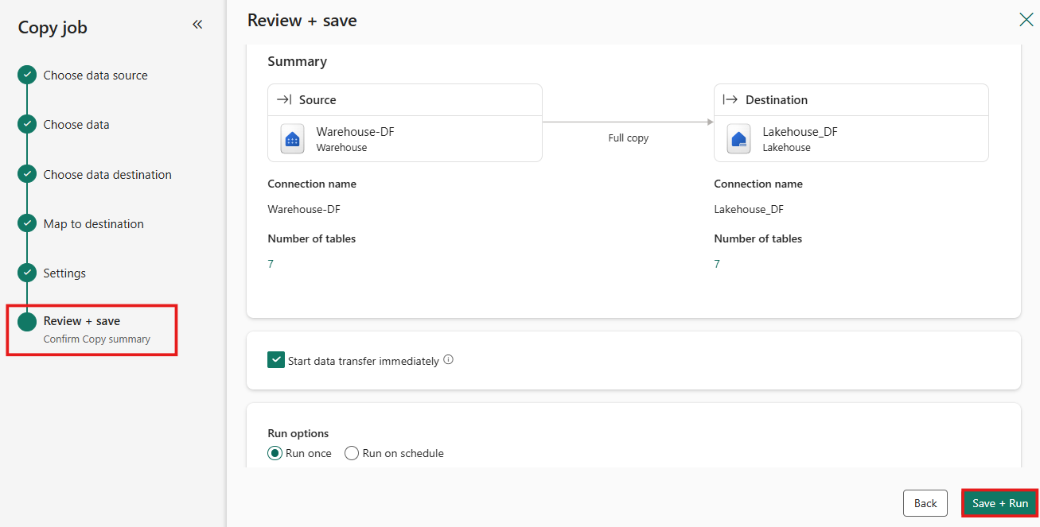Review the job summary and save it.
7. 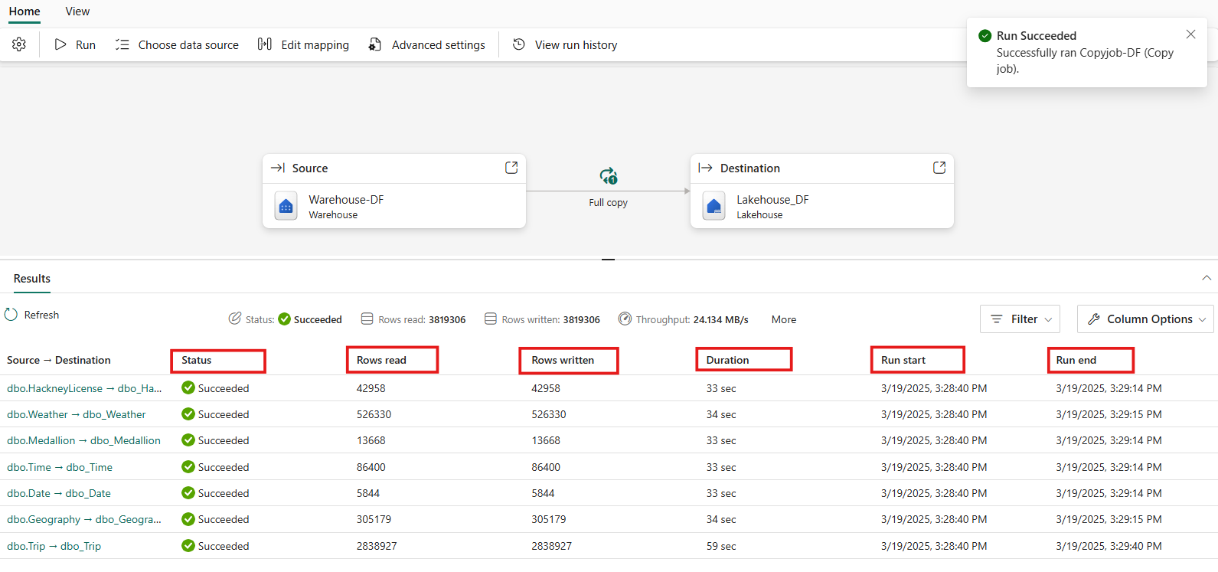In the Copy job panel, you can modify, execute, and track the job's status. The inline monitoring panel displays row counts read/written for the latest runs only. The successful completion will take 4-5 mins.
8. You can also see the data availability in the data destination.

## Exercise 3 – Monitor a Copy job in Data Factory

### **Task-1: Monitor in the Copy job panel**

Follow these steps to monitor a copy job in copy job panel.

1. 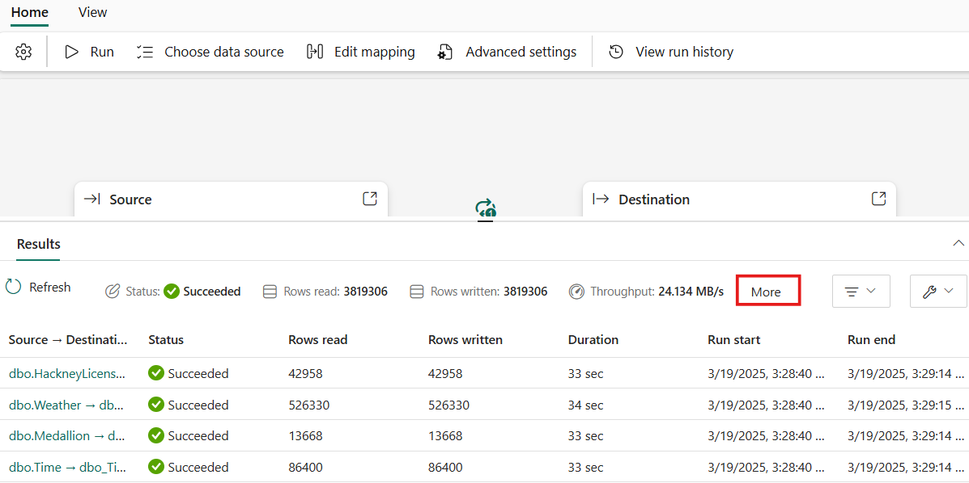Select **More** to see more details about the job, including the run ID, which is useful if you need to create a support ticket.

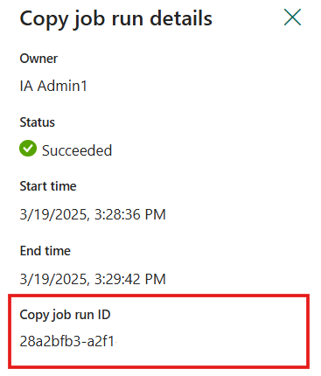

1. 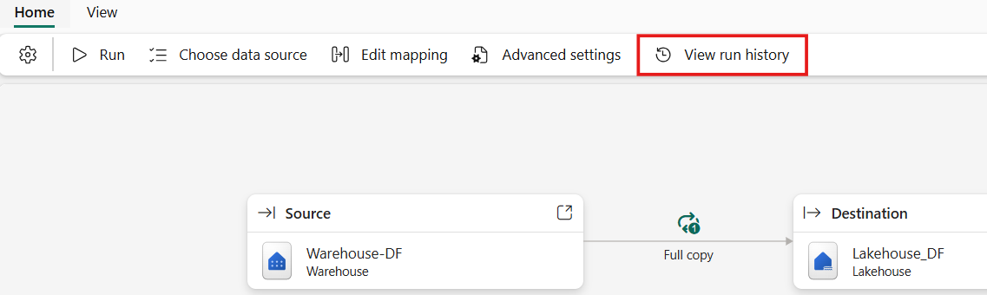You can also select **View run history** to see a list of prior runs.

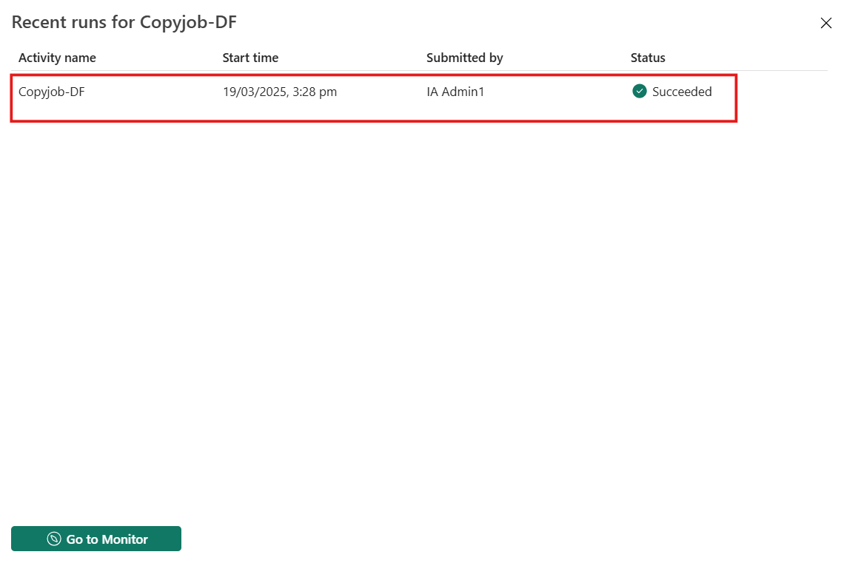

### **Task-2: Monitor in the Monitoring Hub**

The Monitoring hub serves as a central portal for overseeing Copy job runs across different items. There are two ways to access the Monitoring hub.

1. When you select the **View run history** button on the Copy job panel Results area to view the recent runs for your job, you can select **Go to Monitor**.

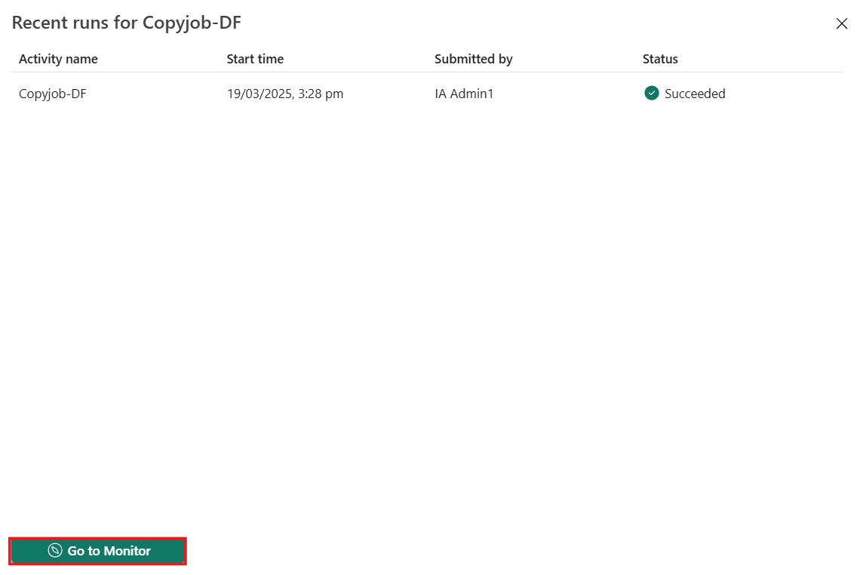

1. 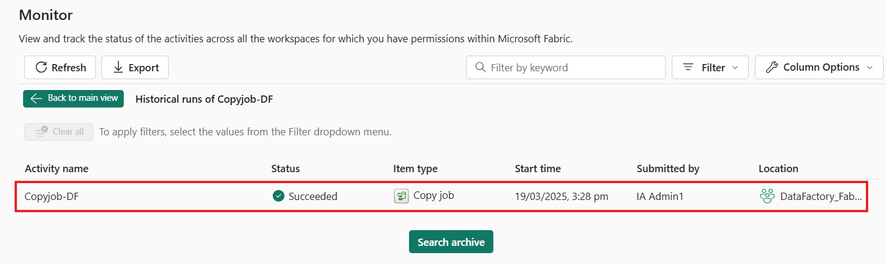This will navigate you to the Monitoring hub, where you can see a list of all Copy jobs and their runs.